QC-DEL-WO/98-FP-6 Wohlenberg Quad-Creaser - Installation of Blanking Spacers
Blanking Spacer code: QC-WO/SP
The Tech-ni-Fold Wohlenberg Quad-Creaser is a flexible system capable of producing up to 4 close-proximity creases simultaneously for perfect bound book applications (2 x spine creases and 2 x hinge creases).
If less creases are required for a particular style of creased book cover, then the Split Rubber Creasing Ribs can be removed from the Creasing Components and quickly and easily replaced with Tech-ni-Fold’s Blanking Spacers. See below for instructions on the installation procedure.
Utilising the Blanking Spacers will enable the Creasing Components to be completely closed up during production, reducing the risk of the Components coming apart during production.

Step 1
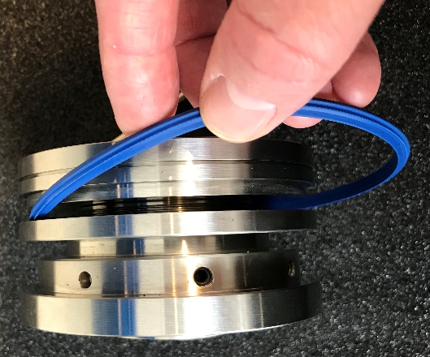
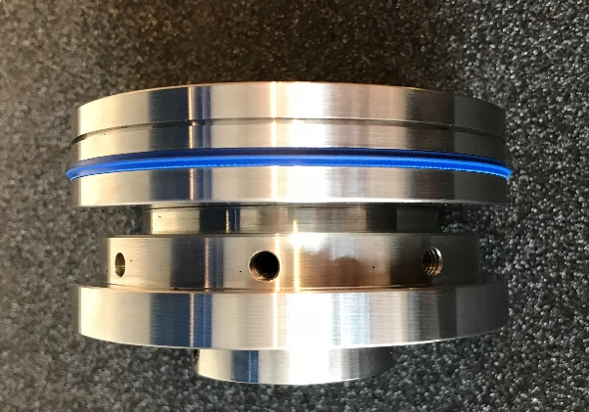
Removing the Split Rubber Creasing Rib
Loosen the 2x 6mm screws in the locking collar.
Screw apart the locking collar and mandrel to release the Split Rubber Creasing Rib.
Screw together the locking collar and mandrel until hand tight.
Using the supplied Hex Tool tighten the 2x 6mm screws in the locking collar.


Step 2
The above installation procedure can be performed with the Creasing Components in situ on the machine tooling shafts.
Step 3
Repeat Steps 1 & 2 for the opposite Creasing Component if only requiring the 2x Spine Crease application.
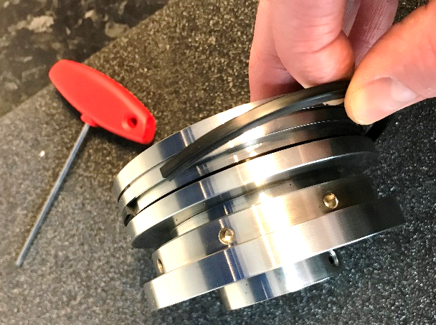
Insert the Blanking Spacer Component
Insert a Blanking Spacer into the recess left by the removal of the Split Creasing Rib.
Installation is easy as the Blanking Spacer design is split and so quickly located into the recess.
